Linux commands
1. creating sh file

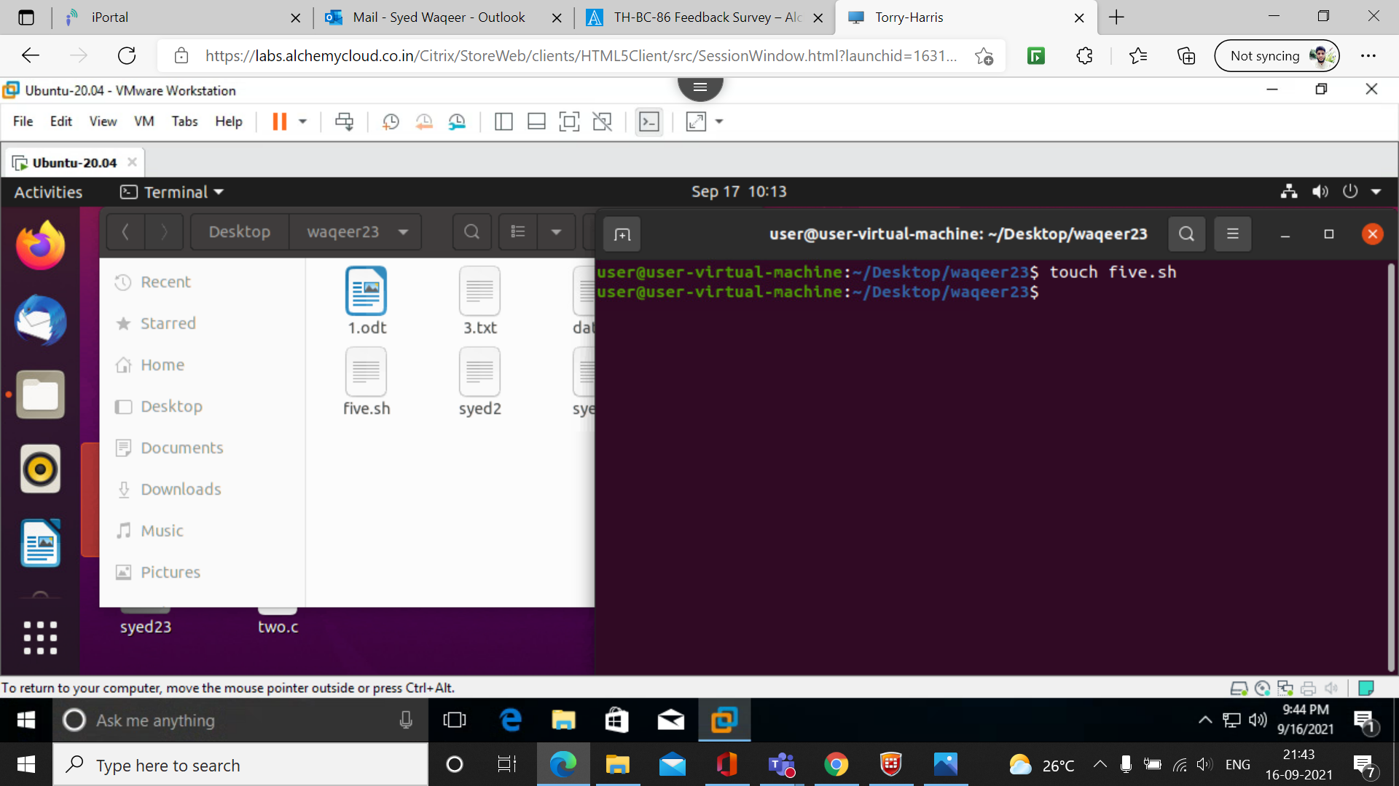
2.
changing the modes of sh file

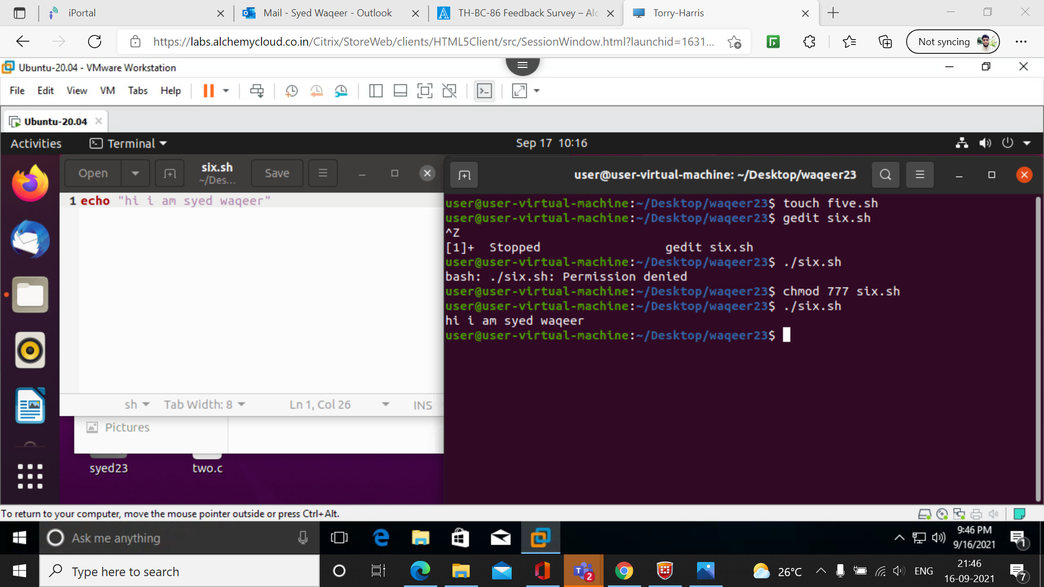

3.
for creating and deleting the directory.
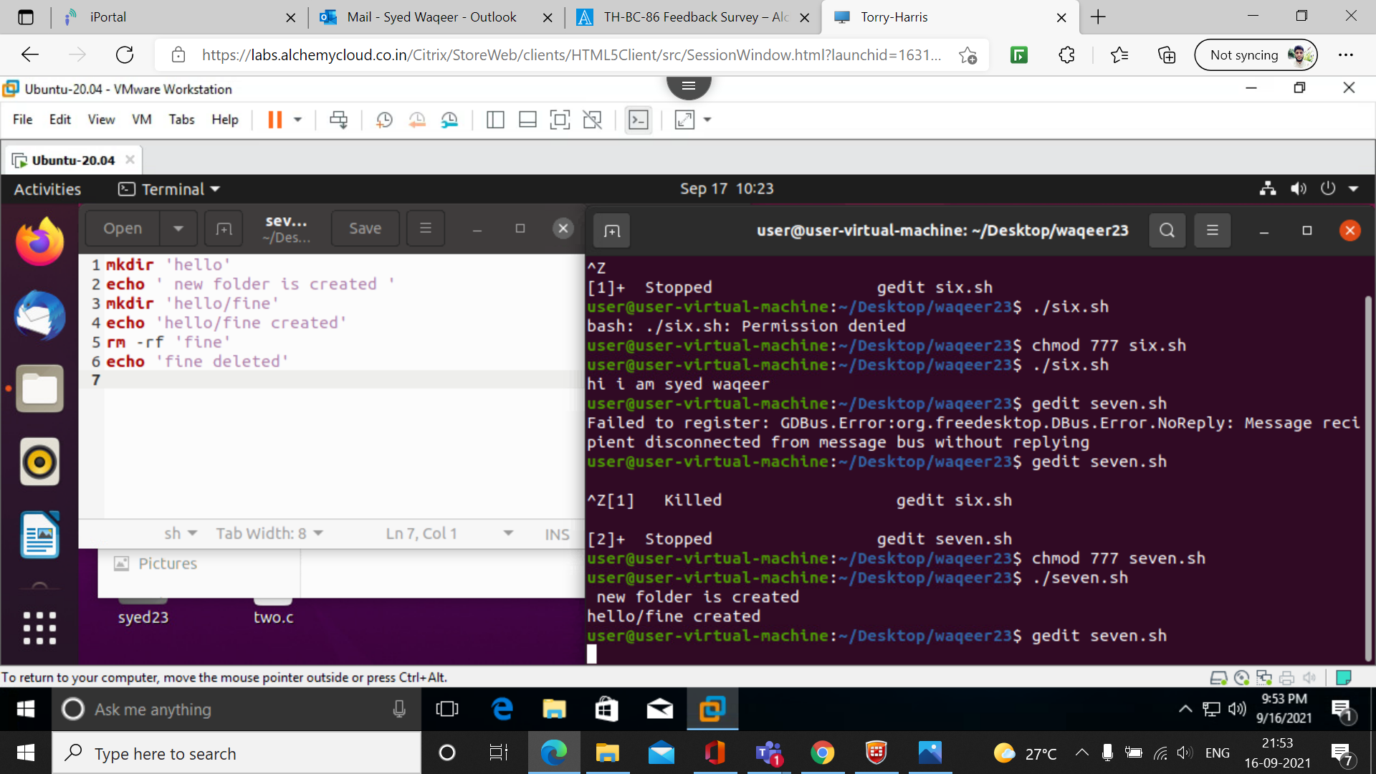
4.
here we are executing
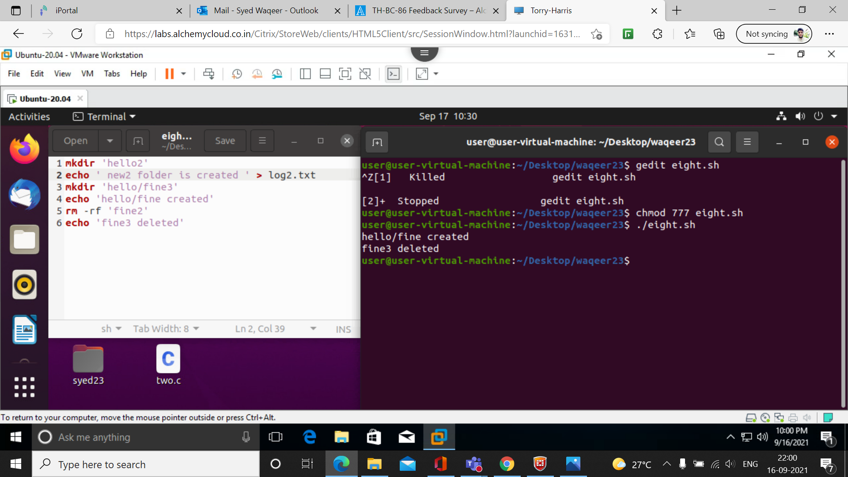

5. program of simple interest

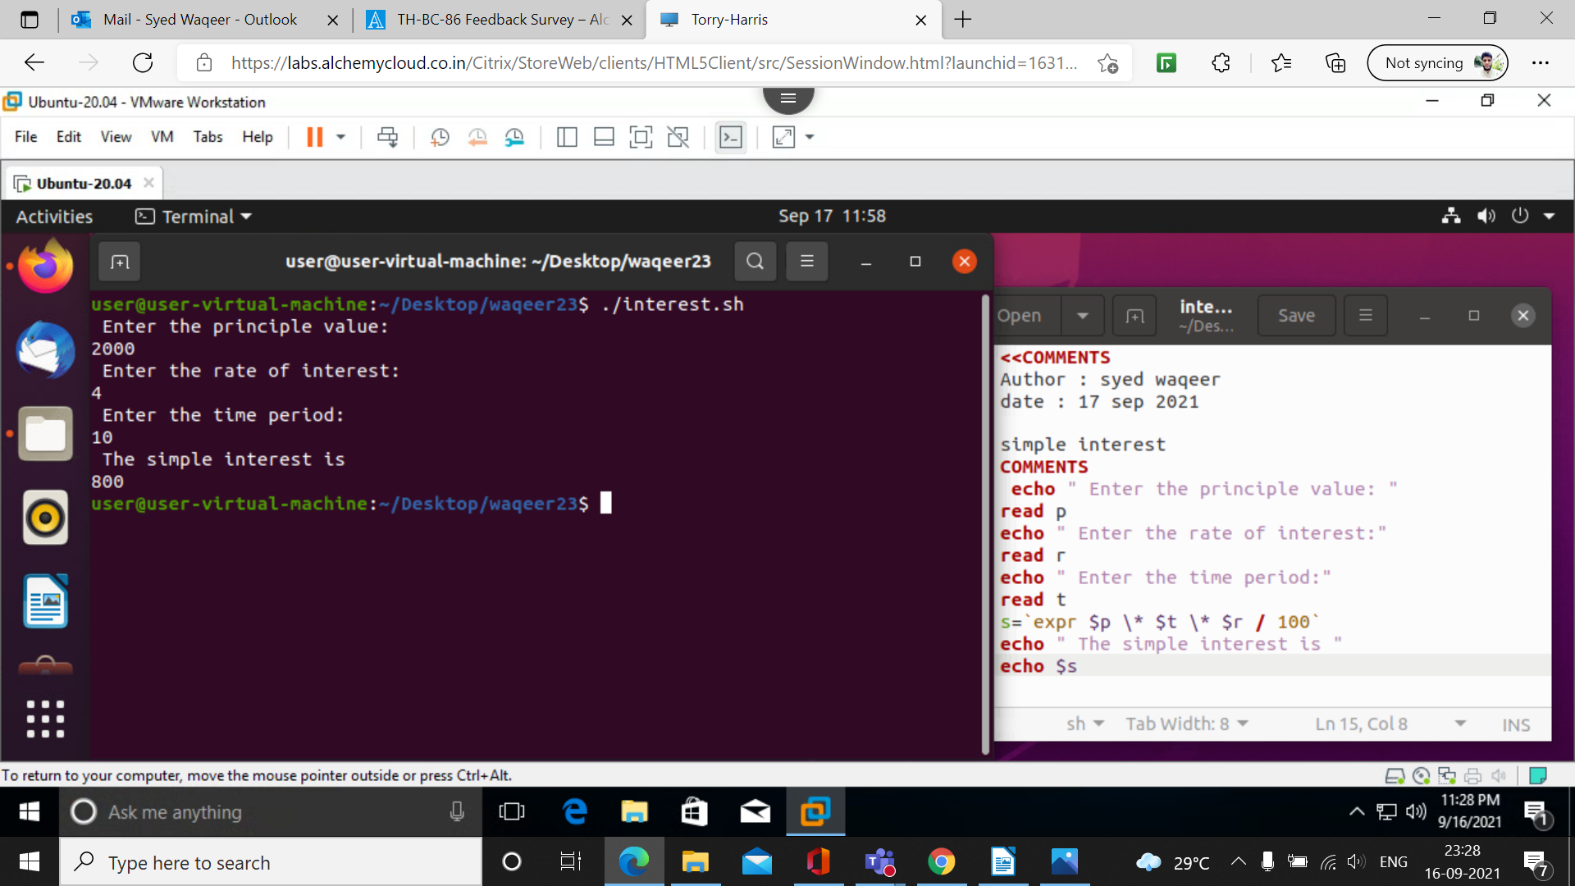
6. program circumferance of circle

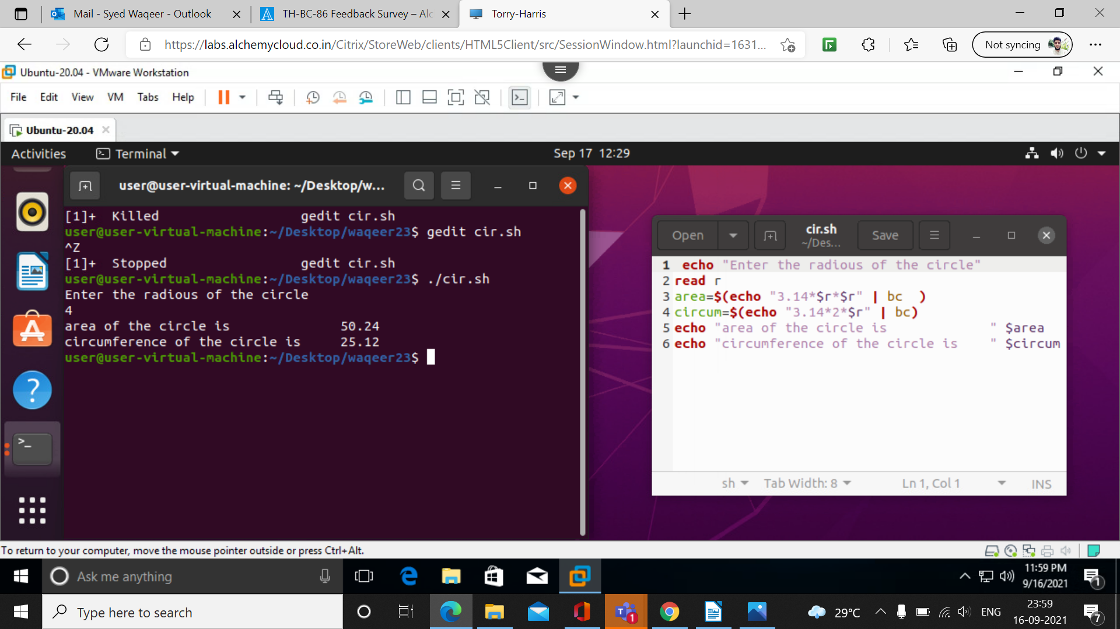

7. write a program to display table.

echo "Enter a Number"
read n
i=1

while [ $i -le 10 ]
do
echo " $n x $i = $(( n * i ))"
i=$(( i + 1 ))
done

8.write a program to display this pattern
*
**
***
****

rows=4
for((i=1; i<=rows; i++))
do
for((j=1; j<=i; j++))
do
echo -n "* "
done
echo
done

